Assignment 1

1. Create dynamic web application. It will have login logout function.
2. Create login page and submit the form to a servlet.
3. Pre-define some user-password combinations.
4. If the user name and password are correct. Show success page. Otherwise failure page.

Assignment 2

1. After the user logged in. Display user name on top corner of the page.
2. Show a logout link. Once click on it. Log out the user.
3. Display links: Add Department, Add Employee.
4. Once click on Add Department, show a page to add department with necessary fields. On the page, there are two buttons, one is Save, one is Cancel.
5. Once click on Add Employee, show a page to add employee with necessary fields. Save and Cancel button.  
   Notice: since there is no database involved. Once the session is closed, all information is gone.

Assignment 3

1. Show Department/Employee information using jstl c foreach

Log In page:

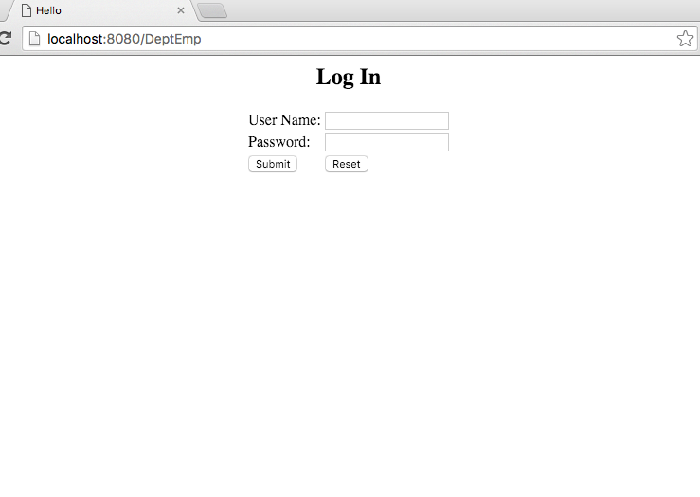

Error Msg:

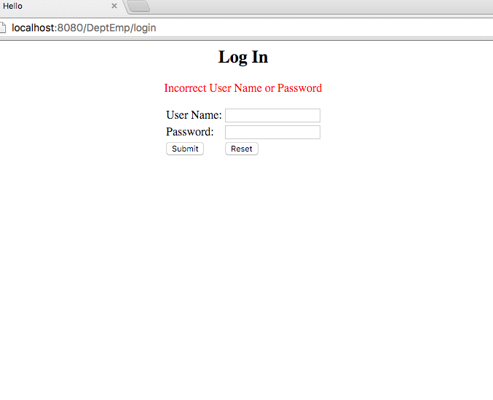

Success Login:

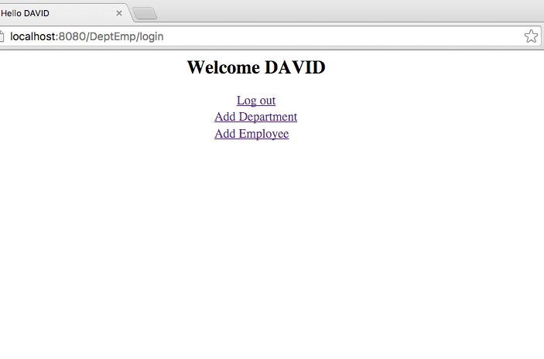

Add new employee page:

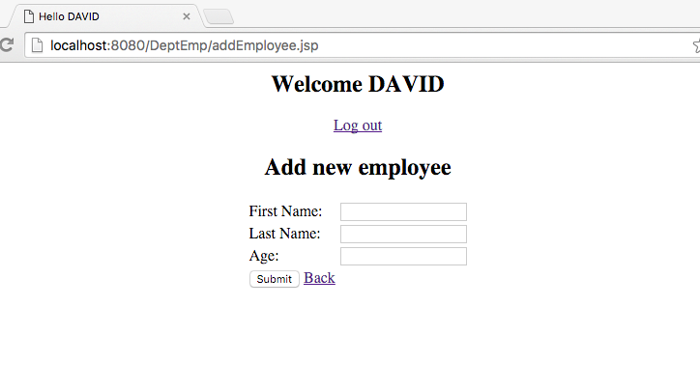

display existing employee:

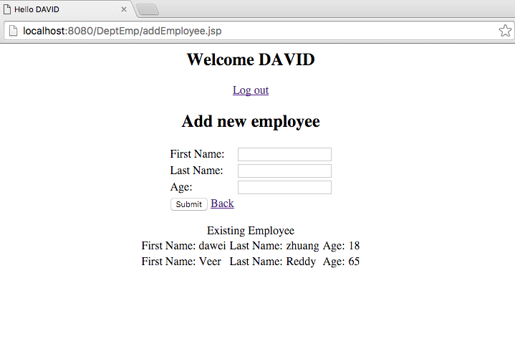

Add new department page

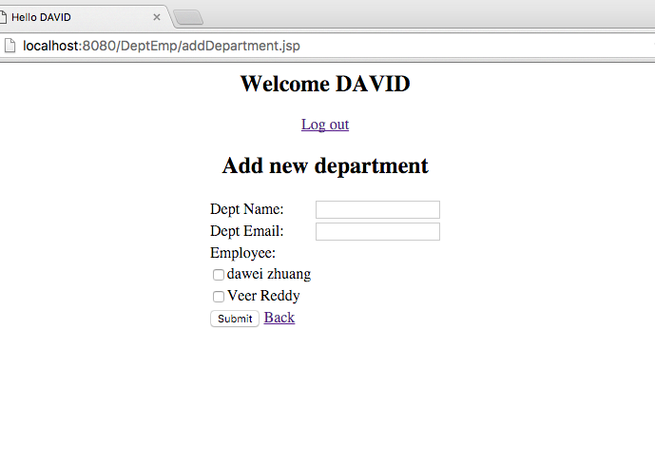

input, select multiple employees:

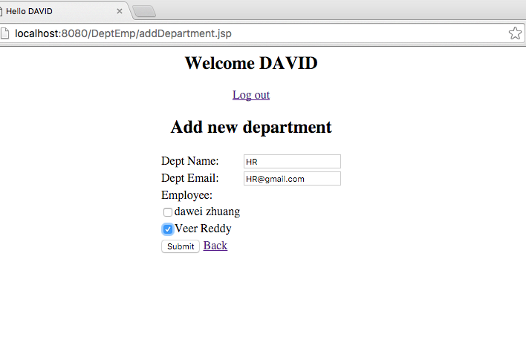

Display the existing department:

